**What if machines are capable of doing tasks that humans were only capable of performing?**

Citing an example to my above statement, let's say what if machines are capable of having any physical skill, imagining things or showing emotions or critical thinking? Well to my astonishment, judging song contests, driving automobiles, and detecting fraudulent transactions are three examples of the complex tasks that machines are now capable of simulating.

But these all things simulate a sense of what if questions in our mind. What if machines are capable of doing all the above tasks and they replace human's job? What if intelligent machines turn on us in a struggle of the fittest? What if intelligent machines produce offspring with capabilities that humans never intended to impart to machines? What if legend of singularity (hypothetical point in time at which growth becomes uncontrollable and irreversible, resulting in unforeseeable changes to human civilization) becomes true?

All these questions arise a fear of losing jobs in one's mind. According to joint research from the Office for National Statistics and Deloitte UK published by the BBC in 2015, job professions including bar worker (77%), waiter (90%), chartered accountant (95%), receptionist (96%), and taxi driver (57%) have a high chance of becoming automated by the year 2035.

Data science is a really trending topic nowadays and everyone wishes to be a data scientist but do we really know who are data scientists?

Machines operate based on the statistical algorithms and it is then managed and overseen by skilled individuals known as data scientists and machine learning engineers.

Now you must be wondering what is machine learning?

Machine Learning is a science of programming computers so they can learn from the data. It is the field of study that gives computers the ability of learning without being explicitly programmed. A computer program is said to learn from existing experience E with respect to some task T and some performance measure P, if its performance on T, as measured by P improves with experience E. The examples that the system uses to learn are called "Training sets".

Citing a very common example - your spam filter is a Machine Learning program that can learn to flag spam given examples of spam emails and non-spam emails. Now here that task T is to flag spam for new emails, experience E is the training data and the performance measure P needs to be defined; for example, you can use the ratio of correctly classified emails. This particular performance measure is called accuracy and it is often used in classification tasks. I'll be defining accuracy and other metrics for classification in the upcoming repositories.

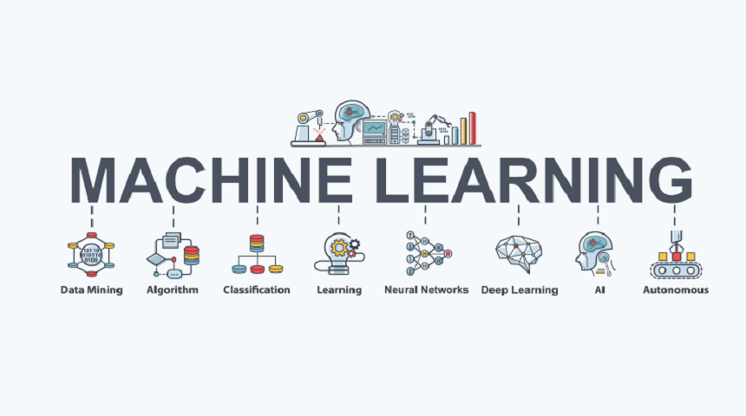

Algorithms derived from classical statistics contribute the metaphorical blood cells and oxygen that powers machine learning.

Input data is fed --------> We select the algorithms --------> Machine is then instructed to conduct its analysis

Machines proceed to decipher patterns found in the data with the use of trial and error. The machine's data model, formed from analyzing data patterns can then be used to predict future results/values.

Machine is formulating decisions based on the experience and mimicking the process of human based decision making.

For example, let’s suppose that after analyzing YouTube viewing habits the decision model identifies a significant relationship among data scientist watching cat videos. Here, the machine analyzed which videos data scientist enjoy watching on YouTube based on user engagement; measured in likes, subscribes, and repeat viewing. Taking another example there is a separate model which identifies patterns among the physical traits of baseball players and their likelihood of winning the season’s Man of the Match award. Here, the machine assessed the physical attributes of previous baseball Man of the Match winners among other features such as age and education. However, at no stage was the decision model told or programmed to produce those two outcomes. By decoding complex patterns in the input data, the model uses machine learning to find connections without human help. This also means that a related dataset gathered from another period of time, with fewer or greater data points, might lead the model to a slightly different output.

In neither of these two was your machine explicitly programmed to produce direct outcomes. You feed the input data and configure the algorithm, but the final prediction is determine by the machine only through self-learning and data modeling.

Now let's say for example while detecting the spam emails in our Spam filter, we say that the emails with suspicious subject lines and body text containing keywords like dear friend, free, invoice, PayPal, Viagra, casino, payment, bankruptcy, and winner that correlate highly with spam messages flagged by users in the past are considered as spam emails. However, as the machine is fed more data, it can also lead to incorrectly classified emails. If there is limited data to reference its decision, the following email subject, for example, might be wrongly classified as spam: “PayPal has received your payment for Casino Royale purchased on eBay.” But this is a genuine email sent from PayPal auto-responder and therefore this will lead to a case of false positives (it wasn't a spam mail in reality but the machine considered it as spam) So, Machine learning models are trained to form decisions based on past experiences and hence incorporates exposure to data to refine its model, adjust its assumptions, and respond appropriately to unique data points such as the scenario described.